The LLUAD Survey is a custom app created with ESRI Web AppBuilder and Survey123 which allows users to record land use categories and other information against land parcels. The app is designed for mobile devices with GPS and internet connectivity. The app can be used by anyone with Logan City Council credentials.

**System Requirements**

The following operating systems (with minimum versions) are supported for the Survey123 field app and Survey123 Connect:

|  |  |  |
| --- | --- | --- |
| **Operating system** | **App** | **OS version** |
| Windows | Survey123 field app  Survey123 Connect | Windows 11 Pro and Windows 11 Enterprise minimum version 21H2 (64 bit)  Windows 10 Pro and Windows 10 Enterprise minimum version 1809 (64 bit)  Windows Server 2016 (64 bit)  Windows Server 2019 (64 bit) |
| Android | Survey123 field app | 6.0 Marshmallow or later (ARMv7 32 bit and ARMv8 64 bit) |
| iOS | Survey123 field app | 13 or later (64 bit) |

The following are the minimum requirements for running the Survey123 field app or Survey123 Connect on Windows devices:

|  |  |
| --- | --- |
| **Hardware** | **Requirement** |
| CPU speed | 2.2 GHz minimum or higher; Hyper-threading (HHT) or Multicore recommended |
| Processor | Intel Pentium 4, Intel Core Duo, or Xeon Processors; SSE2 minimum |
| Platform | Windows 11 Pro and Windows 11 Enterprise minimum version 21H2 (64 bit)  Windows 10 Pro and Windows 10 Enterprise minimum version 1809 (64 bit)  Windows Server 2016 (64 bit)  Windows Server 2019 (64 bit) |
| Memory/RAM | 2 GB or higher |
| Display properties | 24-bit color depth |
| Screen resolution | 1024x768 recommended or higher at normal size (96 dpi) |
| Swap space | Determined by the operating system; 500 MB minimum  ArcGIS Runtime will create cache files when used; additional disk space may be required. |
| Video/Graphics adapter | Accelerated graphics card driver  OpenGL version 2.1 minimum runtime is required for 2D map views; OpenGL version 3.2 is required for 3D scene views. Shader Model 3.0 minimum is recommended. Be sure to use the latest available driver. |

Hardware requirements are not listed for Android and iOS because on these platforms the operating system version is the best indicator of whether the Survey123 field app is supported on that device. For more information on Survey123 system requirements see [here.](https://doc.arcgis.com/en/survey123/get-started/systemrequirements.htm)

**Installation**

1. Install ArcGIS Survey123 (free) via Google Play or the App Store:

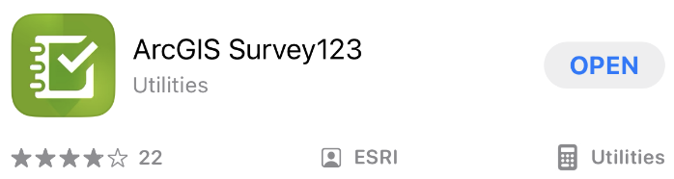

1. Open Survey123 and log in with your Logan Council credentials.
2. Download the 2024 LLUAD Survey to the Survey123 app via [this link](https://arcg.is/1XyOD01) or the QR code below:



**Use**

1. Open Survey123 and select ***LLUAD Survey 2024:***

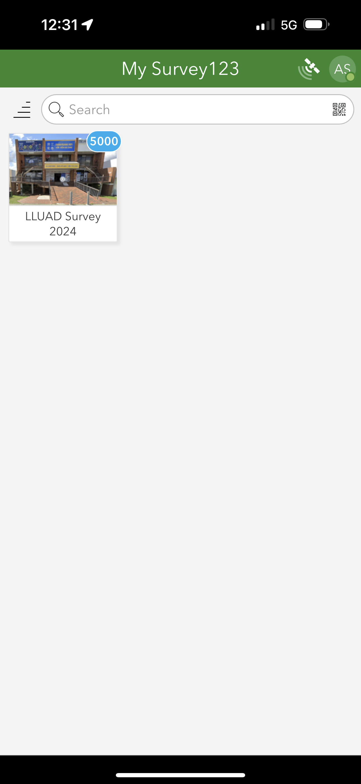

1. Click the ***Inbox*** button on the survey page and then the ***Refresh*** 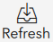 button in the inbox. This will download the survey data to the device:

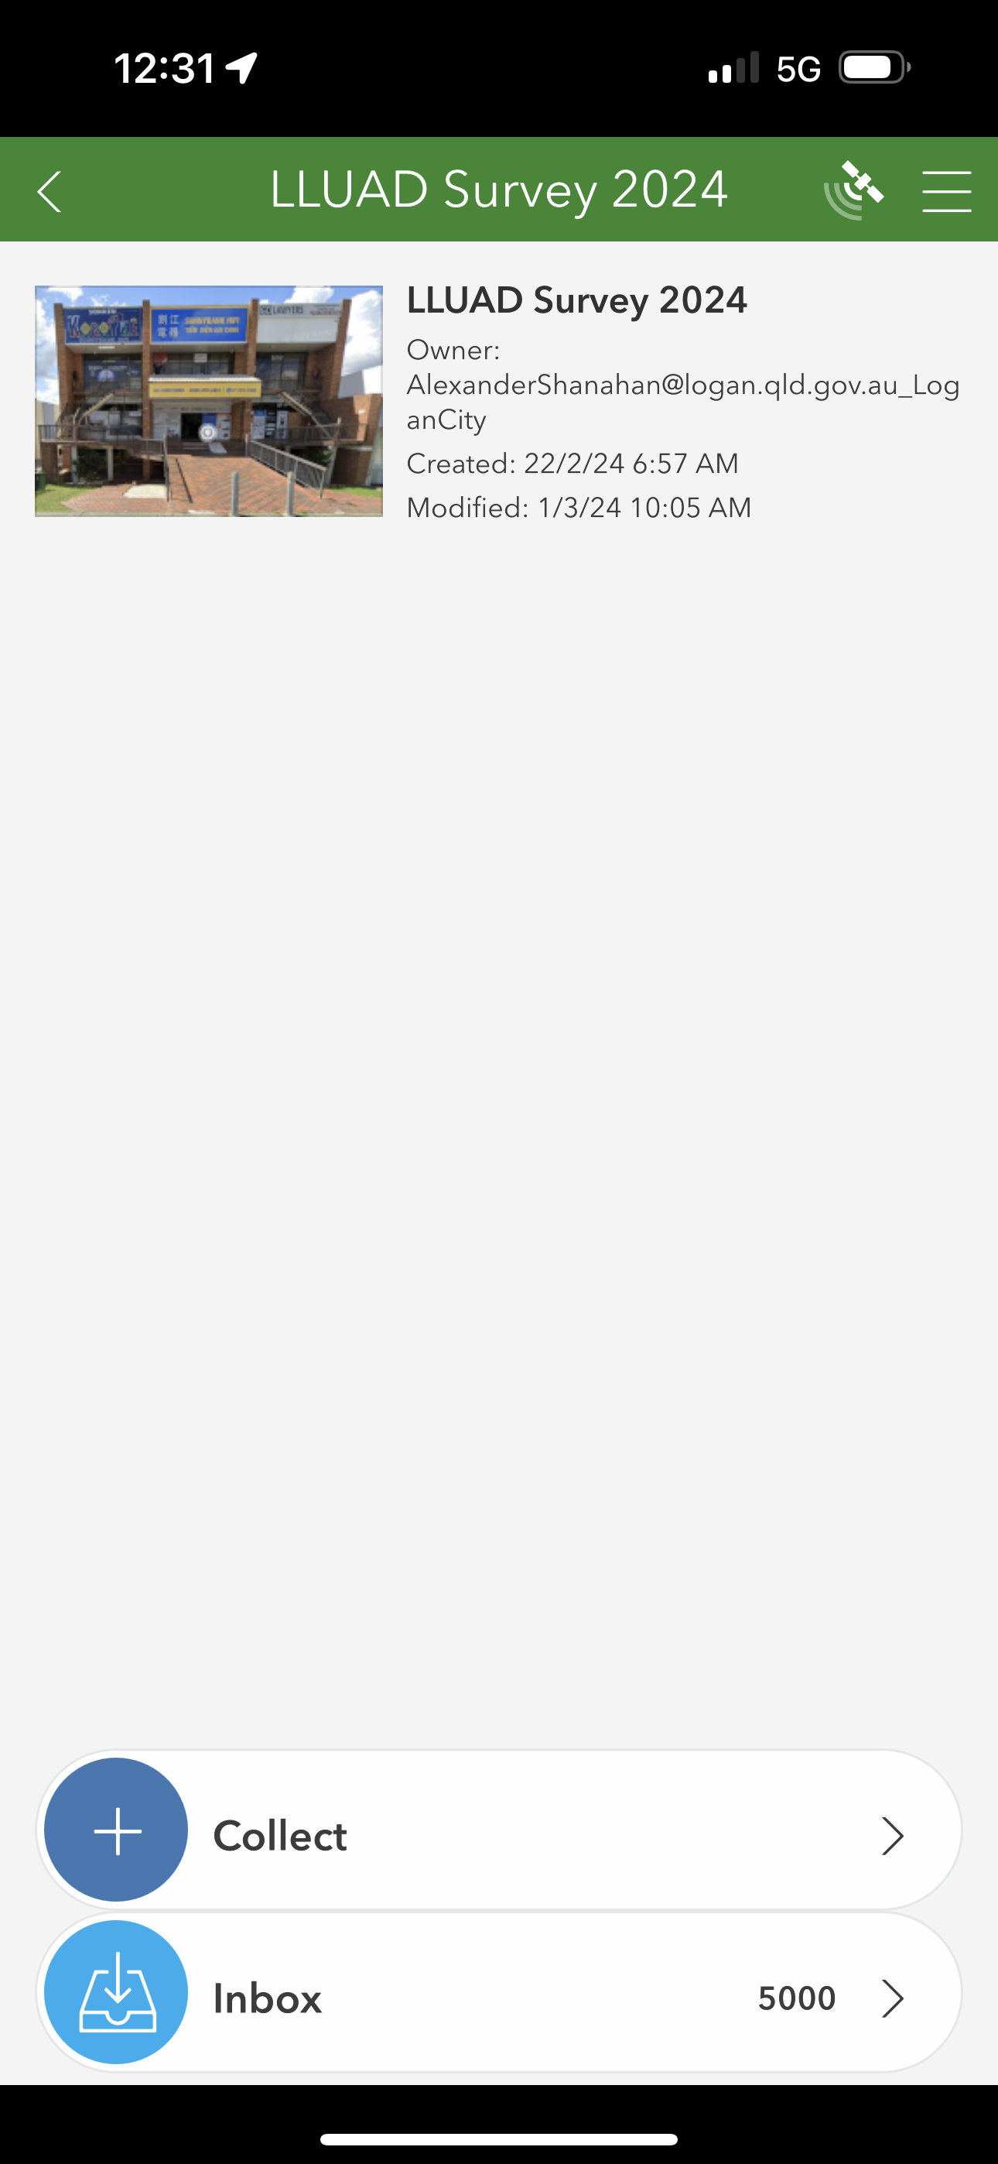 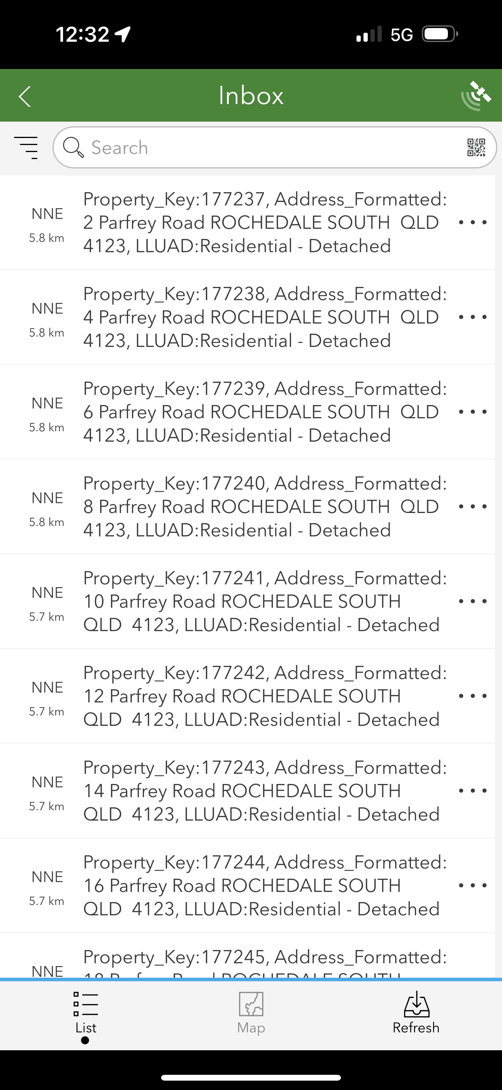

1. Press the ***Map*** 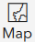 button and then the ***My Location***  button in the map to scroll the map to your current location:

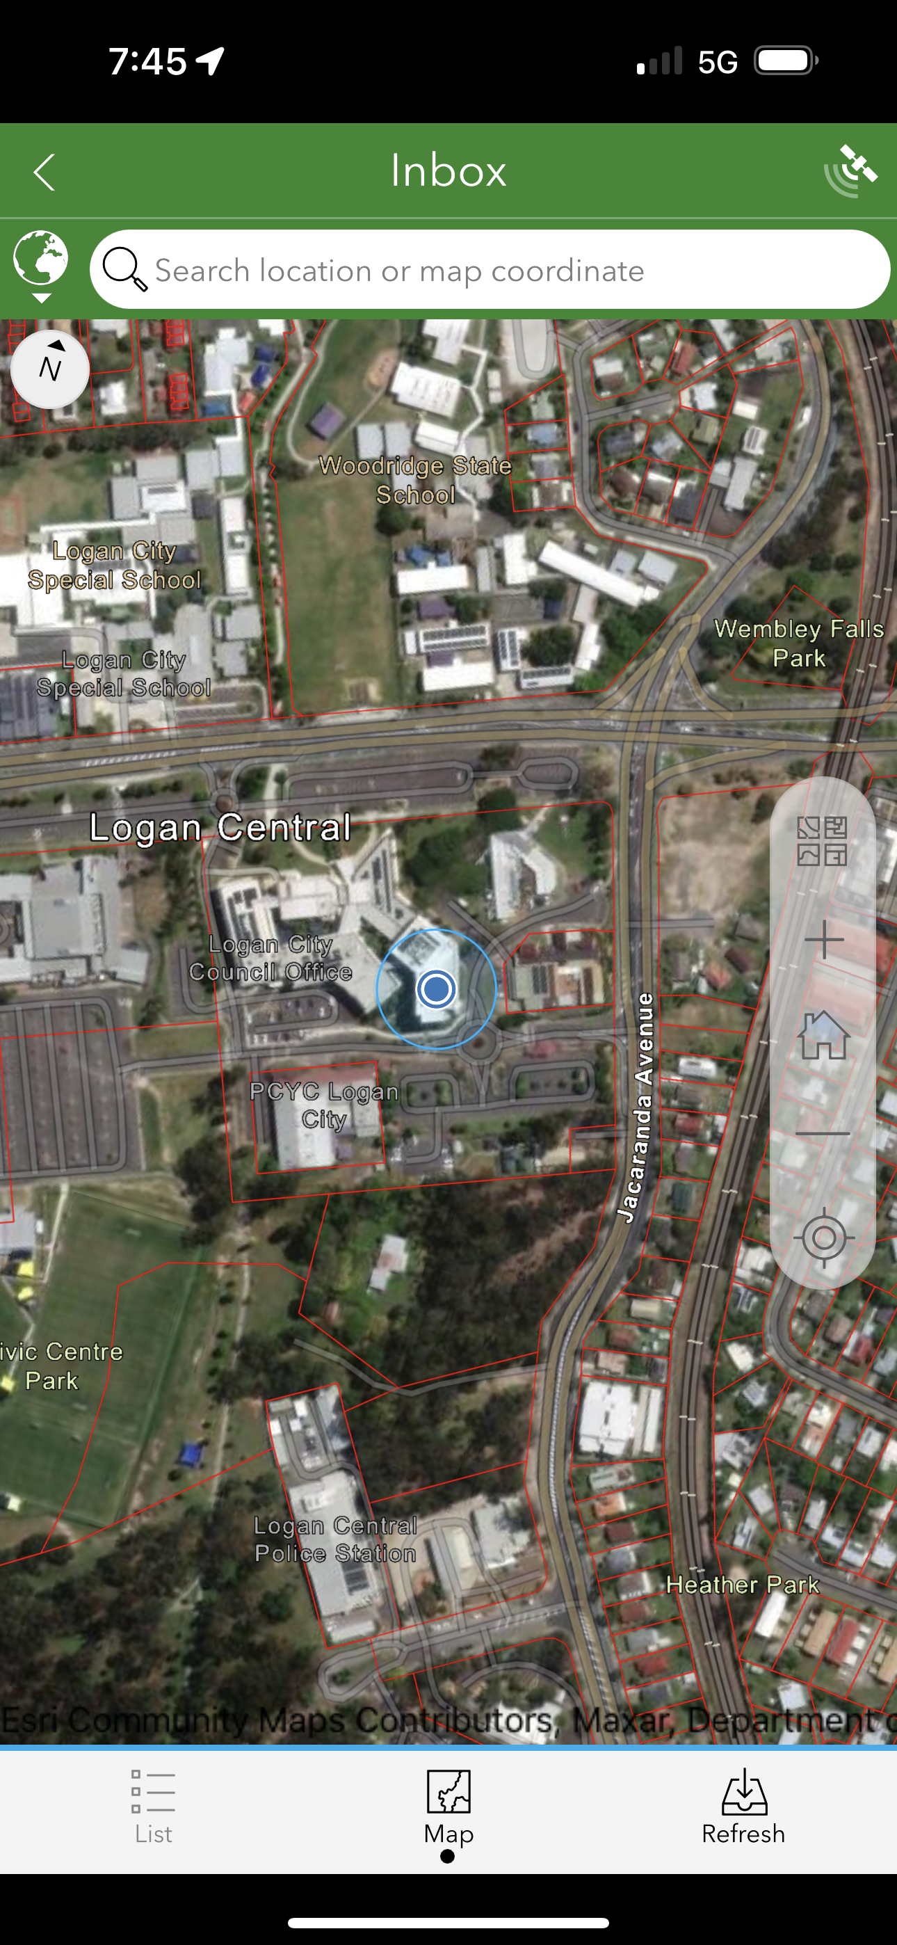

1. Press the ***Refresh***  button to refresh the records for land parcels in your current location:

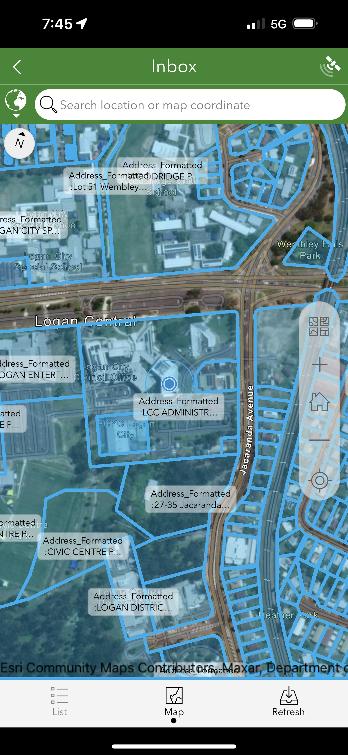

1. Select a land parcel to open the form for that parcel:

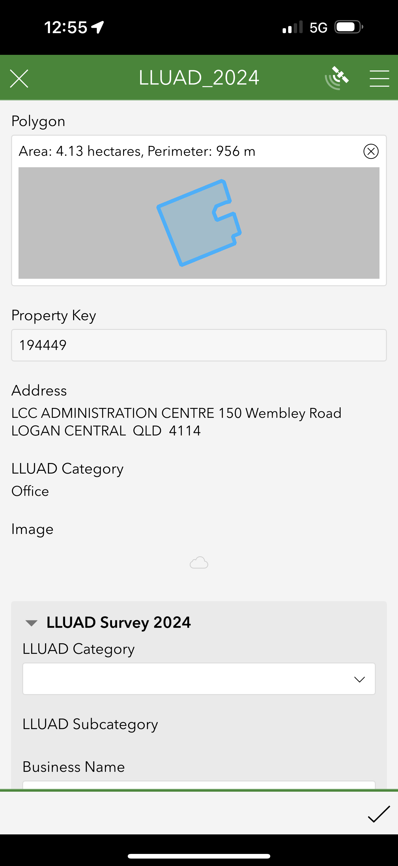

1. Select a *LLUAD Category* for the land parcel which most accurately reflects the current land use. See the table below for the available land use categories to choose from. If there is no suitable category in the list, leave this field blank.

|  |
| --- |
| **LLUAD Categories** |
| Attached dwelling |
| Semi-detached dwelling |
| Detached dwelling |
| Secondary (including Auxiliary unit) |
| Retirement/Care - High care (beds) |
| Retirement/Care - Low care (dwellings) |
| Residential - Other |
| Residential - Non-Private |
| Shot-term accommodation (beds) |
| Shot-term accommodation (units/dwellings) |
| Education |
| Health |
| Community-Other |
| Office |
| Retail and services |
| Showroom and Bulk Goods |
| Low impact industry |
| Medium impact industry |
| High impact industry |
| Warehouse distribution & logistics |
| Sport Tourism and Recreation |
| Rural |
| Open Space |
| Vacant Land |
| Excluded |

1. Select a *LLUAD Subcategory* for the land parcel. This field will only populate in the form when a LLUAD Category is selected.
2. Enter the *Business Name.* This field is compulsory. The maximum number of characters for this field is 150.
3. If necessary, use the notes field to record any other information about the business or land use in the *Notes* field. Up to 255 characters can be recorded in the *Notes* field:

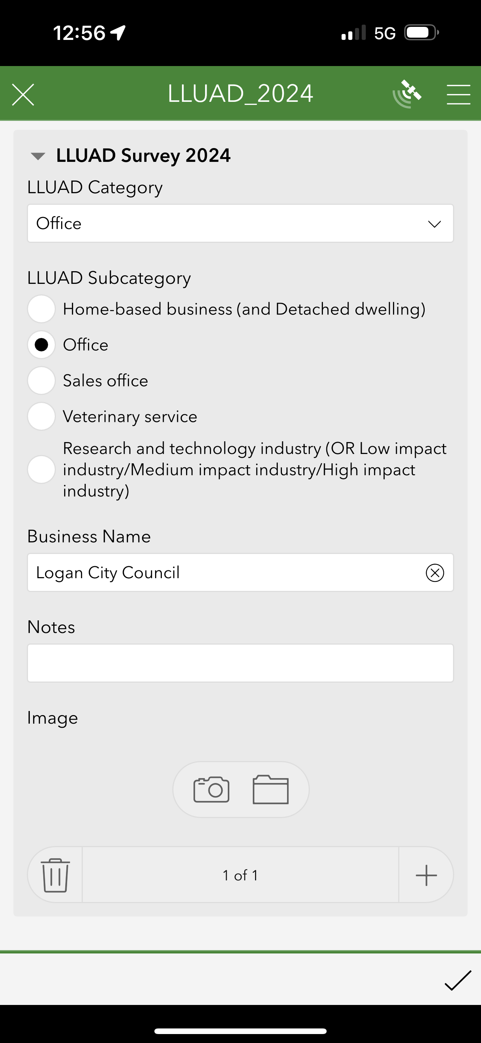

1. Add a photo of the property with the camera built into the device or by uploading a photo:



1. There is no limit to the number of records that can be associated with a land parcel. For locations with more than one business or land use type, additional records can be created by selecting the symbol at the bottom of the form. This will generate a new blank form. Repeat this process as many times as necessary to record information about all businesses/types of land use for the property. All fields in the survey form are optional, except for *Business Name*. Any submitted form can be edited to add, remove or change information.
2. Save the information you have recorded for a land parcel by clicking the  at the bottom of the form.